**Illuminating the Path: A Comprehensive Analysis of African Universities in Webometric Rankings**

In a world that is in a perpetual state of transformation, the significance of education, and consequently, the pivotal role of universities, cannot be overstated. Much like celestial bodies in the vast expanse of the night sky, African universities shine with their own unique radiance, offering a beacon of hope and knowledge to their communities and the world at large. The way these institutions perform on the global stage has become a subject of immense interest and importance. Therefore, this essay embarks on an extensive exploration of the performance of African universities as reflected in webometric rankings. It is our intention to engage in a thorough analysis of this crucial topic, adhering to a writing style that is crystal clear, easily comprehensible, and free from any form of ambiguity.

Across the sprawling landscape of higher education in Africa, universities exhibit a broad spectrum of performance metrics. Visualizations, much like powerful telescopes pointed towards the stars, serve as our guiding tools to navigate this vast cosmic expanse of academic achievement. The histogram, acting as our lens, captures the essence of this diversity. Its portrayal of the distribution of world ranks from 2000 to 2020 provides a vivid snapshot of the academic galaxy. Within this cosmic frame, a significant cluster of universities gravitates toward world ranks ranging from 2000 to 4000. This clustering suggests a semblance of shared characteristics in terms of economic and social development. However, we must not overlook the presence of outliers, universities bearing world ranks of 6000 or 8000, which stand as a testament to the remarkable diversity and individuality within the vast academic cosmos of Africa.

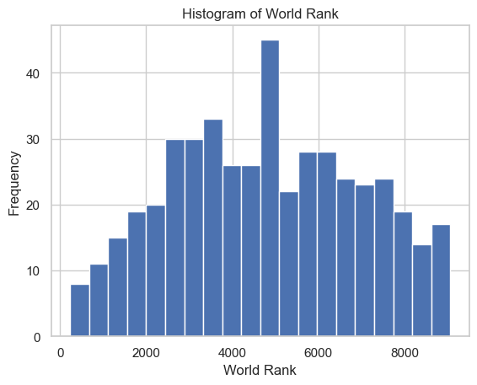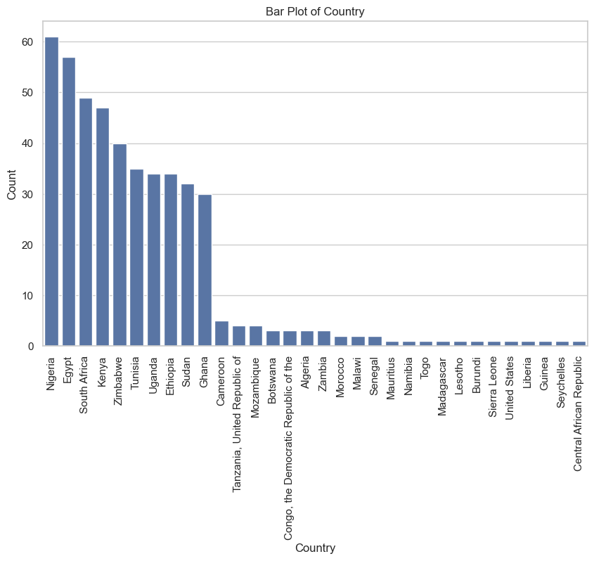

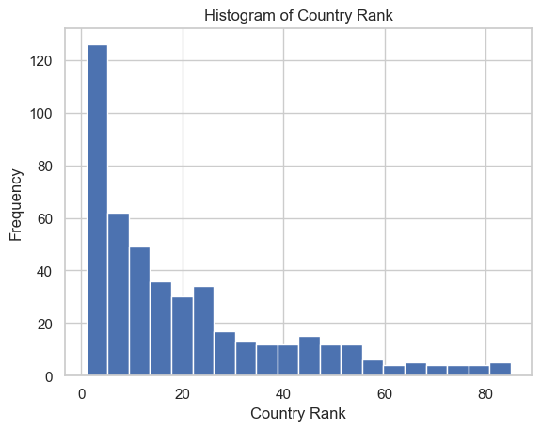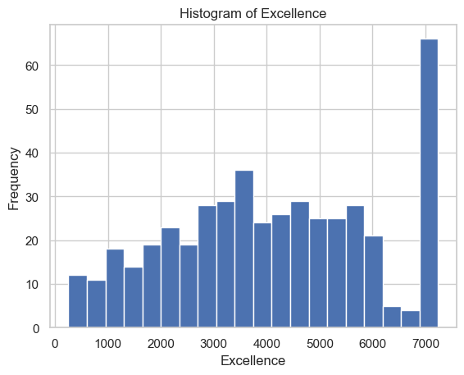

Embarking on a journey through this intricate web of data is akin to setting a course through the boundless cosmos. The scatter plots, acting as our guiding stars, unveil a tapestry of intricate correlations between world rank, impact, openness, and excellence. Within this celestial canvas, a pattern emerges; universities adorned with higher world ranks tend to shine with greater brilliance in these domains of performance. Yet, much like celestial anomalies that defy conventional expectations, exceptions linger in the firmament. Among them are universities that, despite bearing lower world rankings, radiate with remarkable impact. These outliers serve as a celestial reminder, emphasizing that world rank, while significant, is not the sole compass by which to gauge the grand voyage of university performance.

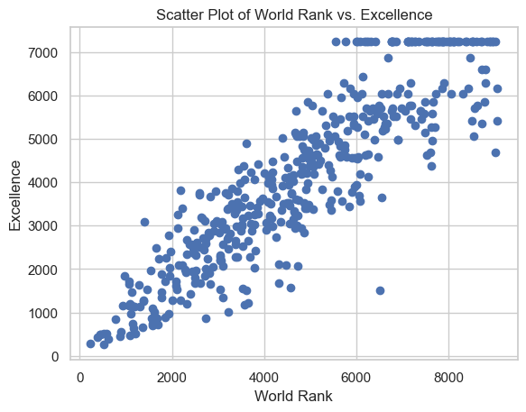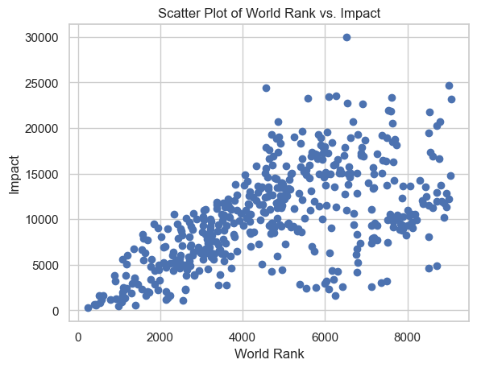

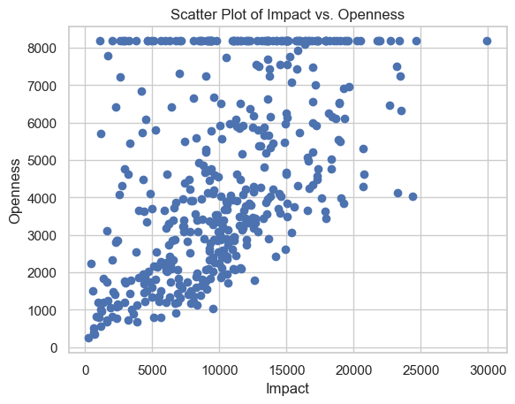

Much like an all-encompassing celestial map that unveils the cosmic relationships between distant stars, the correlation heatmap offers a comprehensive overview of the intricate connections among various numerical features. Within this astral chart, it becomes abundantly clear that excellence, impact, and openness stand as the guiding constellations determining a university's world rank. They shine brightly, their significance undeniable, in the vast cosmic expanse of academic performance. In contrast, continental and country ranking, while not to be dismissed entirely, occupy relatively dimmer corners in this stellar constellation of factors. Their influence, though relevant, is less pronounced in the grand cosmic dance of university rankings.

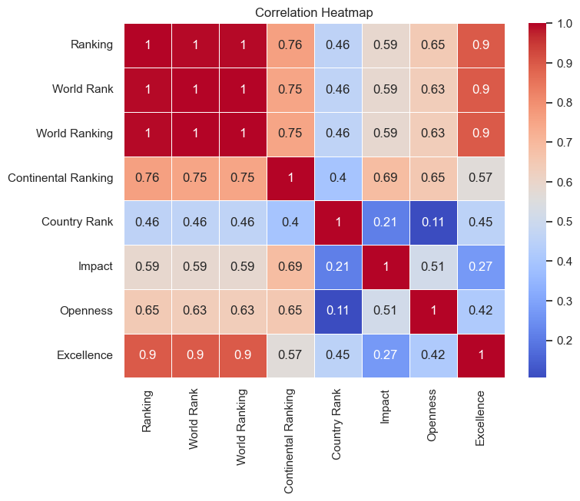

Engaging in a comparative analysis, not unlike the study of diverse ecosystems, opens a door to profound insights into the intricate tapestry of the African higher education landscape. It is akin to embarking on an expedition through the natural world, where each university represents a unique species, playing a role in the grand ecosystem of academia.

In this voyage of exploration, we turn our attention to a visualization that places the performance of the top 30 universities worldwide under the microscope. This visual aid serves as our magnifying glass, revealing a strong correlation between world rank and various other vital metrics. What comes to light is an enchanting dance, a celestial waltz, where top-ranked universities often emerge as luminous stars, radiating brilliance in impact, excellence, openness, and regional/global presence.

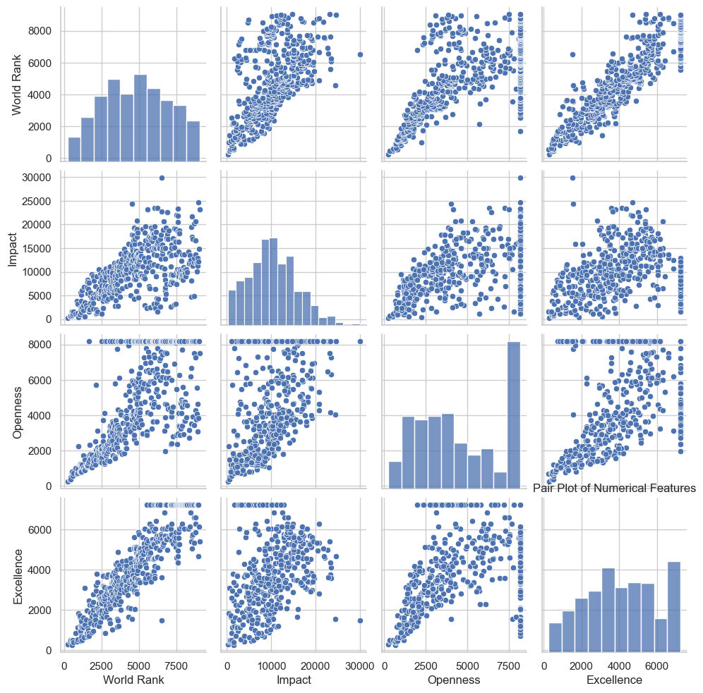

Yet, in this vast academic galaxy, akin to our cosmos, each star bears its unique characteristics. There exist outliers, such as the University of Oxford, which shine with a distinct radiance that defies conventional patterns. These academic anomalies serve as celestial wonders, demonstrating that even within the tapestry of top-ranked institutions, individuality and uniqueness persist.

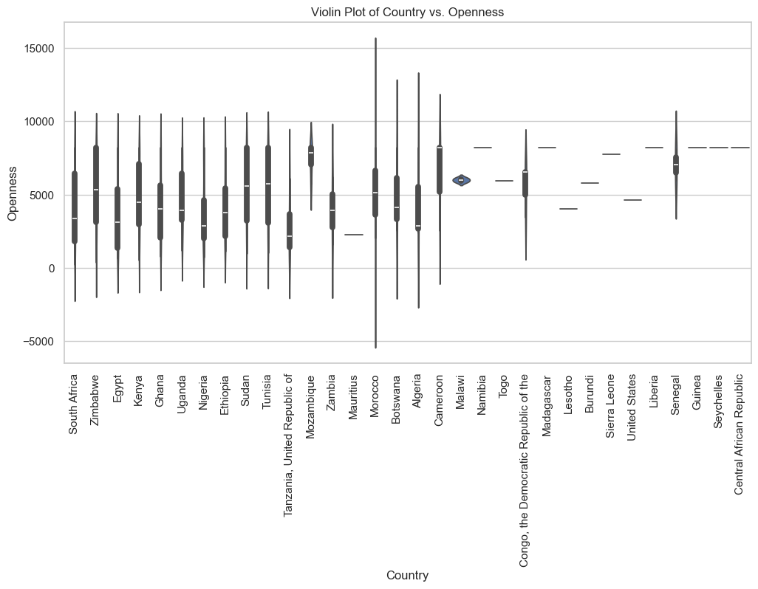

Much like ecologists studying diverse ecosystems to comprehend the intricate web of life, the comparative analysis provides valuable insights into the world of higher education. It emphasizes the importance of world rank and its interconnectedness with other vital metrics, shedding light on the symbiotic relationships that shape the academic landscape. It is a reminder that, while patterns and correlations are essential, there will always be unique and exceptional entities within the grand universe of academia.

cccccccccccccccc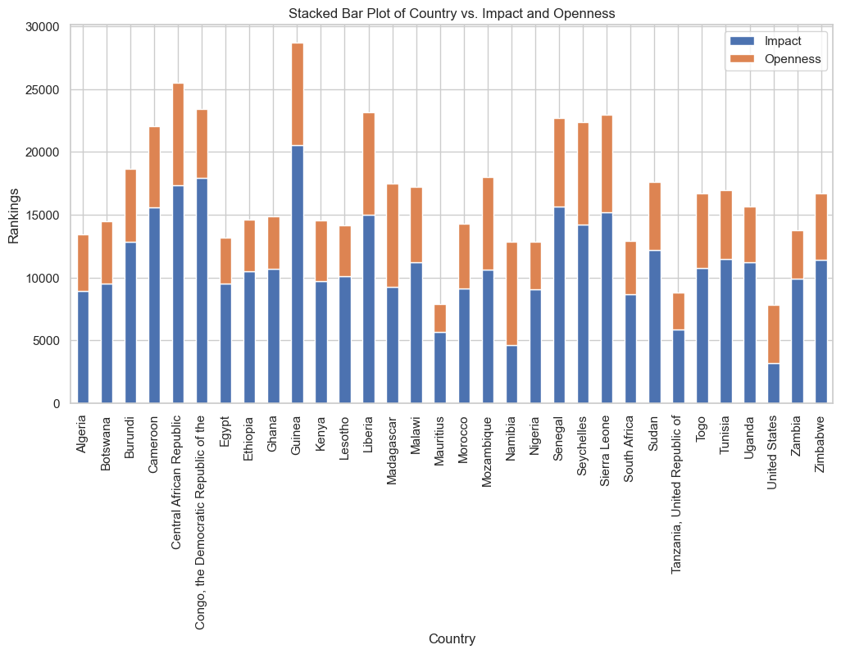

As we turn our gaze toward the horizon of the future, a set of recommendations emerges, acting as guiding stars for African universities on their unceasing quest for excellence:

* **Investing in Research Output:**

Much like nurturing the roots of a mighty tree, dedicating resources to bolster research output stands as a cornerstone recommendation. This investment has the potential to yield manifold benefits, contributing not only to higher world rankings but also to the overall performance of universities. Research output serves as the fertile soil from which the academic ecosystem thrives.

* **Fostering Collaboration and Openness:**

Akin to nurturing a vibrant ecosystem, fostering collaboration and openness should be at the forefront of university strategies. The academic environment should be akin to a lush forest, teeming with diversity and cooperation. Such an atmosphere not only catalyses an increase in impact and excellence but also ensures the harmonious coexistence of ideas and perspectives, driving progress.

* **Addressing Economic Disparities:**

Much like tending to the soil, addressing economic disparities is of paramount importance. Economic development, like the nourishing rain, uplifts the standard of living and paves the way for better education. By addressing these disparities, universities can not only improve their world rankings but also enhance academic metrics, ultimately contributing to a thriving educational landscape.

In conclusion, the trajectory of African universities resembles a celestial journey, with each institution akin to a unique star within the vast cosmic expanse of higher education. The visualizations and data we have delved into unveil a complex universe, teeming with diversity and untapped potential.

These insights do not merely serve as academic curiosities but as valuable tools that universities, policymakers, and stakeholders can utilize to navigate the uncharted cosmic terrain of African higher education. It is a roadmap, much like the constellations that guided ancient explorers, that can lead the way forward.

By working in synergy, universities, policymakers, and stakeholders can collectively raise the bar of higher education across the African continent. In doing so, they illuminate the path of knowledge and innovation, casting a brilliant beacon on the global academic horizon. It is a journey that beckons us all, inviting us to explore the limitless possibilities and embrace the boundless potential that awaits in the ever-expanding cosmos of African academia.